**DESIGN AND DEVELOPMENT OF IOT BASED PORTABLE BIOMEDICAL KIT FOR HEPATITIS AND JAUNDICE**

**ABSTRACT:**

Bilirubin is a compound which is yellow in shade, happens within the ordinary catabolic pathway is the breakdown made of heme in vertebrates. This catabolism is a necessary technique inside the body's clearance of waste merchandise that get up from the destruction of aged red blood cells. There are two types of bilirubin namely  Conjugated (direct) Bilirubin and Unconjugated (oblique) Bilirubin. The un-conjugated Bilirubin is Albumin-bound in serum and by no means present in urine whereas Conjugated Bilirubin is unbounded in serum and it's miles present in urine. Our proposed concept is set to determine the amount of Conjugated Bilirubin in urine. We build here a easy electronic circuit fashioned of Light-emitting diodes and light dependent resistors that may be used for analysing bilirubin concentration. We recommend this method due to the fact the Boiled Rice grains have the capability to absorb Bilirubin pigment. This Biomedical package is used to detect the Jaundice and Hepatitis affected sufferers via quantitative analysis of bilirubin in urine.

**INTRODUCTION:**

The liver has the entirety to do with how we stay, this is why it is referred as liver. The kingdom of your liver may have a huge bearing upon how nicely you stay, how long you may stay and the way you will appear and feel. In ultra- modern world, the liver has to exert more difficulty than ever before, and everywhere in the world we find that liver issues are growing. Globally, one in each ten individuals suffers with a few form of liver, bile duct or gall bladder ailment. The most common ailments were jaundice and hepatitis which more than 2 million people suffer annually due to late analysis and treatment. Early analysis and treatment can save about 60% of the patients who were unaware of their pathological conditions.

Measurement of the amount of bilirubin in blood serves only as a very rough indicator of the condition your liver is in. A measurement frequently involves a device where electronics plays an important role. This Device detects the Jaundice and Hepatitis from the urine by finding the concentration of bilirubin in urine. Bilirubin occurs in the normal catabolic pathway of all vertebrates. This catabolism is Urine bilirubin may also be clinically significant. Bilirubin is normally detectable in the urine of healthy people with in the certain range of concentration. If the amount of conjugated bilirubin in blood becomes elevated, e.g. due to liver disease, high amount of conjugated bilirubin will be found in the urine. It is a necessary process in the body's clearance of waste products that arise from the destruction of aged red blood cells, Bilirubin present in high level may cause certain discharged in the urine, indicating a pathological process.

Testing urine for bilirubin which is responsible for the yellow colour of lesion, marks in various parts in our body and the yellow discoloration in urine gives us the insight of the pathological condition based on concentration of bilirubin in it. Its subsequent breakdown products, such as stercobilin, cause the brown colour and urobilinogen can help differentiate Obstructive liver disease from other causes of jaundice. This device gives us the information on whether the patient is affected with Jaundice and Hepatitis or not by quantitative analysis of bilirubin in urine.

**MATERIALS:**

Urine sample, Test tube, Digital Calorimeter, Boiled Rice, Containers, Filter paper, Distilled Water, Resistor, LED (450nm (Blue), 620nm (Orange), 700nm(red)), IOT(Arduino)

**METHOD**

In this method we make use normal and abnormal persons. First of all we want to collect the fresh urine sample from that persons. Some prescription drugs can cause a false positive, or a higher-than-normal reading of bilirubin in your body. Some false positives results indicate high bilirubin level that aren’t necessarily associated with liver disease. The following drugs are:

1. Diuretics

2. Birth Control Pills

3. Steroids

4. Barbiturates

5. Sulfonamides

Urine analysis is painless, but it requires a time commitment and attention to detail. A thorough and accurate test requires to collect urine. The urine sample collected in morning is highly concentrated. Collect the samples from all the persons in the containers. Test the absorbance of each sample using the digital calorimeter before adding rice to the sample and tabulate it. After the sample analysis without rice, the cup of rice is boiled in distilled water. First inspect the urine sample in the spectrophotometer and measure absorbance at 450nm, 620nm, 700nm wavelength. Then pour some rice grains in the urine sample and left it undisturbed for regular interval of time. Filter out the grains from the urine and measure the absorbance at same wavelength once again on that tested urine sample. Now take the necessary calculation to get the result. Two parameters have been made into considerations, they are absorbance and concentrations. i.e., Absorbance α Concentration.

Tests and Methods we utilized so far requires the collection of blood from the patients to test the amount of bilirubin concentration in the blood. The blood sample is obtained through ventricle puncture: A needle is inserted into a vein through the skin in your arm or hand, and a small amount of blood is collected in a test tube.  you will need to not eat or drink anything other than water for four hours before you have the test performed. There are some very rare risks to taking a blood sample: light headedness or fainting, hematoma, a bruise where blood accumulates under the skin, infection, usually prevented by the skin being cleaned before the needle is inserted, excessive bleeding, or bleeding for a long period afterward, which may indicate a more serious bleeding condition and should be reported to your doctor. But urine analysis is non-invasive and facile procedure.

**Values Of Absorbance of Urine Samples in Normal Persons**

|  |  |  |  |  |  |  |
| --- | --- | --- | --- | --- | --- | --- |
| **ABSORBANCE** | 450nm | | 620nm | | 700nm | |
| **PERSONS** | **WITHOUT RICE** | **WITH RICE** | **WITHOUT RICE** | **WITH RICE** | **WITHOUT RICE** | **WITH RICE** |
| PERSONS1 | 0.05 | 0.13 | 0.87 | 0.92 | 0.32 | 0.37 |
| PERSONS2 | 0.09 | 0.15 | 0.86 | 0.88 | 0.33 | 0.34 |
| PERSONS3 | 0.25 | 0.29 | 0.88 | 0.92 | 0.35 | 0.38 |
| PERSONS4 | 0.1 | 0.13 | 0.84 | 0.92 | 0.31 | 0.35 |
| PERSONS5 | 0.16 | 0.26 | 0.85 | 0.92 | 0.31 | 0.37 |
| PERSONS6 | 0.05 | 0.1 | 0.82 | 0.85 | 0.29 | 0.32 |

**Values Of Absorbance of Urine Samples in diseased Persons**

**(A)JAUNDICE**

|  |  |  |  |  |  |  |
| --- | --- | --- | --- | --- | --- | --- |
| **ABSORBANCE** | **450nm** | | **620nm** | | **700nm** | |
| **PERSONS** | **WITHOUT RICE** | **WITH RICE** | **WITHOUT RICE** | **WITH RICE** | **WITHOUT RICE** | **WITH RICE** |
| **PERSON 1** | 1.07 | 0.9 | 1.26 | 1.02 | 0.34 | 0.28 |
| **PERSON 2** | 1.19 | 1.01 | 1.17 | 0.94 | 0.45 | 0.34 |
| **PERSON 3** | 1.2 | 1.02 | 1.32 | 1.05 | 0.6 | 0.5 |
| **PERSON 4** | 1.27 | 1.07 | 1.35 | 1.14 | 0.55 | 0.46 |
| **PERSON 5** | 1.34 | 1.28 | 1.26 | 1.04 | 0.3 | 0.25 |
| **PERSON 6** | 1.11 | 0.94 | 1.09 | 0.81 | 0.27 | 0.24 |

**(B)HEPATITIS**

|  |  |  |  |  |  |  |
| --- | --- | --- | --- | --- | --- | --- |
|  | **450nm** | | **620nm** | | **700nm** | |
| **PERSONS** | **WITHOUT RICE** | **WITH RICE** | **WITHOUT RICE** | **WITH RICE** | **WITHOUT RICE** | **WITH RICE** |
| **PERSON 1** | 1.47 | 0.87 | 1.51 | 1.23 | 1.11 | 0.87 |
| **PERSON 2** | 1.56 | 1.29 | 1.47 | 1.22 | 1.32 | 1.09 |
| **PERSON 3** | 1.38 | 1.01 | 1.37 | 1.1 | 1.27 | 0.92 |
| **PERSON 4** | 1.54 | 1.17 | 1.5 | 1.09 | 1.48 | 1.16 |
| **PERSON 5** | 1.66 | 1.37 | 1.61 | 1.33 | 1.6 | 1.32 |
| **PERSON 6** | 1.72 | 1.35 | 1.65 | 1.3 | 1.47 | 1.07 |

**Values Of Absorbance of Urine Samples in Normal Patients**

**Values Of Absorbance of Urine Samples in hepatitis Persons**

**Values Of Absorbance of Urine Samples in Jaundice Persons**

**IMPLEMENTATION:**

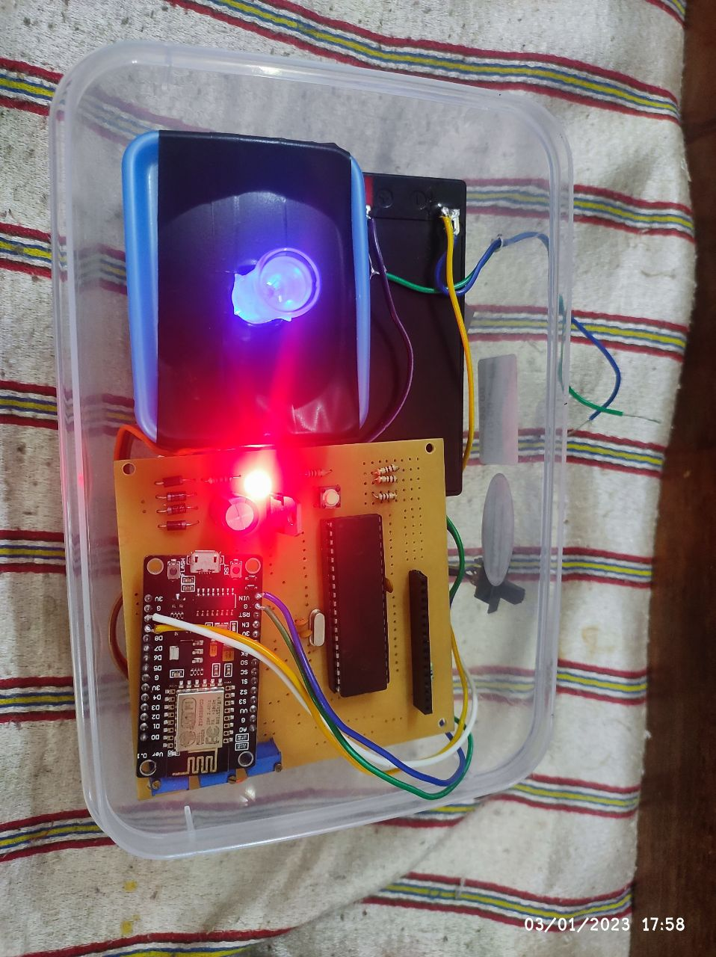The Device consists of a set of seven discrete elements. These elements are light emitting diodes (LEDs) aligned opposite to light-dependent resistors (LDRs) and IOT device. After the sample absorbs light coming from the LED, the LDR senses the change in light intensity, which is expressed as a change in the output voltage from a voltage divider working at constant input voltage. Therefore, when the equation of a voltage divider is used, it is possible to quantify the absorbance. The schematic diagram of the electronic circuit designed for the device as shown in Figure. An IOT device is used to decide on the colour of the LED to be used: blue, orange, or red. To achieve this, the LED terminal should be connected to the positive terminal of IOT (Vcc in the diagram). The source of voltage or power source is also connected to a resistor (100 Ω) and a LDR in series. Notice that there is a LDR for each LED and that they are aligned one opposite to each other. Between the 100 Ω resistor and the LDR, a connection is placed to obtain a voltage divider circuit. Then it is connected to the positive relative connector meanwhile the negative relative connector is connected to the ground terminal GND. All components are housed on a closed setup, which gives a stable position for the cuvette. To select a LED and perform the measurements, IOT runs the program to select each LED’s one by one and collects the voltage output from them. The collected information are used to calculate the absorbance by using the formula fed into the program and analythem to check the bilirubin concentration in the urine. A 9 V DC battery is used as a Power Source, but we have observed that batteries discharge after only three or four experiments, drifting the voltage during an experiment and hampering good results.

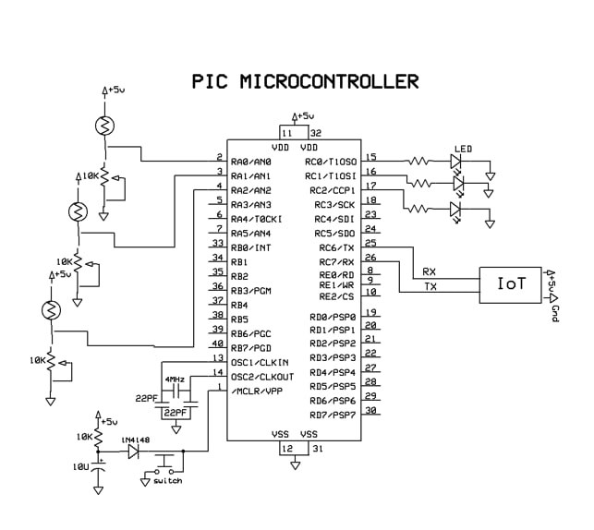

**RESULT CONCLUSION:**

The low compliance towards invasive blood-bilirubin monitoring is pervasive. Up to 37% of people with Jaundice and 12% with Hepatitis do not implement the required bilirubin monitoring schedule. Inadequate blood-bilirubin monitoring leads to long­ term health consequences of jaundice. The development of feasible monitoring technologies is instrumental for adherence to the self-monitoring of blood bilirubin. Invasive testing yields precise results. However, the risk of skin infections and the associated pain makes it unsuitable for continuous bilirubin monitoring. Research on non-invasive blood bilirubin monitoring has led to the development of various devices, easing jaundice and hepatitis management through comfortable, minimally invasive/non-invasive continuous blood-bilirubin monitoring. Nevertheless, they still suffer from issues such as lag time and the requirement of frequent calibration. Urine analysis is a budding domain for non-invasive disease diagnosis and monitoring. It is safe, painless, and allows repetitive sampling.

However, the intricacies of urine analysis need to be well-studied to enable reliable, accurate, and reproducible monitoring. The foundation for this approach includes the correct identification of urine biomarkers and associated metabolic pathways. UriLyzers(urine analyzer) are emerging as a solution to the lack of identification of specific biomarkers, but their success depends on the diversity and size of the reference library database. The next stage is urine sampling, which is a major determiner of the performance of a urine analysis system. The targeted phase of the excreted urine is a cardinal point of concern. A sensing unit with proper limits of detection, sensitivity, selectivity, size, stability, durability, response/recovery time, and cost is vital for reliable analysis. Furthermore, the unit needs to be customized to sustain the effects of excreted urine variables, such as acid-base balance, specific gravity, leukocyte esterase, urobilinogen, blood and temperature.

|  |  |  |  |  |
| --- | --- | --- | --- | --- |
| **Person** | **Device Result** | **Laboratoty Result** | **Device Bilirubin Concentration(moles/litres)** | **Laboratory Bilirubin Concentration(moles/litres)** |
| 1 | Normal | Normal | 0.543 | 0.568 |
| 2 | Hepatitis | Hepatitis | 2.1 | 2.29 |
| 3 | Out of constraint | Out of constraint | 3.87 | 4.1 |
| 4 | Jaundice | Jaundice | 1.052 | 1.16 |
| 5 | Jaundice | Jaundice | 1.004 | 1.23 |
| 6 | Normal | Normal | 0.522 | 0.535 |
| 7 | Hepatitis | Hepatitis | 2.209 | 2.45 |

**REFERENCE**:

1. Cashore W. A brief history of neonatal jaundice. Med Health R I 2010;93:154–5.
2. Kaplan M, Bromiker R, Hammerman C. Severe neonatal hyperbilirubinemia and kernicterus: are these still problems in the third millennium? Neonatology 2011;100:354–62.
3. Moncrieff G. Bilirubin in the new born: physiology and pathophysiology. Br J Midwifery 2018;26:362–70.
4. Erlinger S, Arias IM, Dhumeaux D. Inherited disorders of bilirubin transport and conjugation: new insights into molecular mechanisms and consequences. Gastroenterology 2014;146: 1625–38.
5. Memon N, Weinberger BI, Hegyi T, Aleksunes LM. Inherited disorders of bilirubin clearance. Pediatr Res 2016;79:378–86.
6. Devgun MS, Chan MK, El-Nujumi AM, Abara R, Armbruster D, Adeli K. Clinical decision limits for interpretation of direct bilirubin—a CALIPER study of healthy multiethnic children and case report reviews. Clin Biochem 2015;48:93–6.
7. Hansen TWR. Core concepts: bilirubin metabolism. NeoReviews 2010;11:316–22.
8. Cvorovic J, Passamonti S. Membrane transporters for bilirubin and its conjugates: a systematic review. Front Pharmacol 2017;8: 887.
9. Jedlitschky G, Leier I, Buchholz U, Hummel-Eisenbeiss J, Burchell B, Keppler D. ATP-dependent transport of bilirubin glucuronides by the multidrug resistance protein MRP1 and its hepatocyte canalicular isoform MRP2. Biochem J 1997;327: 305–10.
10. Levitt DG, Levitt MD. Quantitative assessment of the multiple processes responsible for bilirubin homeostasis in health and disease. Clin Exp Gastroenterol 2014;7:307–28.
11. Swinehart, D. F. The Beer-Lambert Law. J. Chem. Educ. 1962, 39 (7), 333−335.
12. Andres, R. T.; Sevilla, F. Using the Electrician’s Multimeter in the Chemistry Teaching Laboratory: Part 1. Colorimetry and Thermometry Experiments. J. Chem. Educ. 1993, 70 (6), 514−517.
13. Horowitz, P.; Hill, W. The Art of Electronics; Cambridge University Press: London, U.K., 1989; pp 8−10.
14. Skoog, D. A.; West, D. M.; Holler, F. J.; Crouch, S. R. Fundamentals of Analytical Chemistry; 8th ed.; Brooks/Cole: Belmont CA, 2005; p 1067.
15. Tamura, Z.; Abe, S.; Ito, K.; Maeda, M. Spectrophotometric Analysis of the Relationship between Dissociation, and Coloration, and of the Structural Formulas of Phenolphthalein in Aqueous Solution. Anal. Sci. 1996, 12 (4), 927−930.
16. Missen, R. W.; Mims, C. A.; Saville, B. A. Introduction to Chemical Reaction Engineering and Kinetics; John Wiley & Sons, Inc.: New York, 1999; pp 69−75 and 116.
17. Nicholson, L. Kinetics of the Fading of Phenolphtalein in Alkaline Solution. J. Chem. Educ. 1989, 66, 725−726.
18. Prahl, S. Web Page; Optical Absorption of Methylene Blue; http://omlc.org/spectra/mb/. accessed Jul 2014.
19. Mowry, S.; Ogren, P. J. Kinetics of Methylene Blue Reduction by Ascorbic Acid. J. Chem. Educ. 1999, 76 (7), 970−973
20. Hamzah HH, Zain ZM, Musa NLW, Lin YC, Trimbee E , “Spectrophotometric Determination of Uric Acid in Urine Based- Enzymatic Method Uricase with 4- Aminodiphenylamine Diazonium Sulfate (Variamine Blue RT Salt)”. J Anal Bioanal Tech S7: 011. doi:10.4172/21559872.S7-011, (2013).
21. Stephen R. Delwiche, Maura M. Bean, Raymond E. Miller, Bill D. Webb, And Philip C. Williams4”Apparent Amylose Milled Rice by Near-Infrared Reflectance Spectrophotometry”, American Association of Cereal Chemists, Inc., 1995.
22. Armila Rajbhandari* and Tara Subedit ”Spectrophotometric Determination of TotalIron in Rice and Maize Samples”, Scientific World Vol. 11, No. 11, July 2013.
23. Chauhan N, Pundit CS (2011) “An amperometric uric acid biosensor based on multiwalled carbon nanotube-gold nanoparticle composite”. Anal Biochem 413: 97-103.
24. Rocha DL, Rocha FRP (2010) “A flow- based procedure with solenoid micro pumps for the spectrophotometric determination of uric acid in urine”. Microchemical Journal 94: 53-59.
25. Sanz V, de Marcos S, Galbán J (2008) “Uric acid determination using uricase and the autotransducer molecular absorption properties of peroxidase”. Anal Chim Acta 607: 211-218.
26. Usman Ali SM, Alvi NH, Ibupoto Z, Nur O, Wilander M, et al. (2011) “Selective potentiometric determination of uric acid with uricase immobilized on ZnO nanowires. Sensors and Actuators” B: Chemical 152: 241-247.